Chapter – 1
INTRODUCTION

  - Introduction:
The VoteSecure is a secure web-based voting management system designed to transform the traditional voting process by incorporating biometric face recognition technology. With increasing concerns about voter impersonation, multiple voting attempts, and inefficient manual verification, there is a growing demand for a system that ensures transparency, security, and ease of use in digital elections. VoteSecure addresses these challenges by offering a platform that authenticates users through facial recognition before they are allowed to cast their vote. This method significantly reduces fraudulent activity and strengthens the credibility of the election process. The application is built using modern web technologies such as Node.js and MongoDB for secure data storage and authentication process. The system provides features like voter registration, biometric login, secure vote casting, and real-time result tracking. Only authenticated voters are permitted to cast a single vote, which is encrypted and stored securely to maintain election integrity. VoteSecure also provides a role-based system for administrators who manage candidates, monitor the election process, and publish results. The platform ensures data privacy and system security through encrypted communication and secure access protocols. By minimizing human intervention and reducing the risk of data manipulation, VoteSecure streamlines the entire election process. The integration of face recognition technology not only enhances security but also improves user experience by offering a fast and intuitive authentication process. The application supports deployment across academic, organizational, and government environments, making it a highly scalable and impactful solution for digital voting.

  - Problem Statement:
Traditional voting systems are vulnerable to several challenges including identity fraud, manual verification errors, double voting, and delayed result computation. These issues compromise the fairness and efficiency of elections. Additionally, existing online voting solutions often lack robust user authentication mechanisms, increasing the risk of unauthorized access. There is a pressing need for a secure, fraud-resistant, and user-friendly voting system that can validate voter identity accurately and manage the election process efficiently. VoteSecure addresses these gaps by utilizing facial recognition to authenticate users, eliminate vote duplication, and provide transparent, real-time vote tallying.

  - Objectives:
The main objective of the VoteSecure system is to design and develop a secure digital voting platform using facial recognition for voter authentication. It aims to modernize election procedures while enhancing trust, transparency, and efficiency.
Key objectives include:
- Biometric Authentication: Use AI-powered facial recognition to prevent impersonation and ensure that only valid voters participate.
- Secure Vote Casting: Allow users to cast votes securely after biometric validation, with each vote stored in an encrypted format.
- Role-Based Access Control: Provide administrators with tools to manage elections, verify users, and monitor results securely.
- Real-Time Vote Counting: Enable instant and transparent vote tallying, reducing result declaration time.
- Data Privacy and Security: Protect all user and voting data through encrypted storage and secure communication protocols.
- Scalability: Design the system to support elections of varying sizes, from academic institutions to larger organizational needs.

  - Methodology:
The development of the VoteSecure system followed an Agile Scrum methodology, enabling incremental and iterative delivery of core features. Initial requirements were gathered from stakeholders, defining key modules such as facial recognition-based authentication, secure vote casting, admin controls, and real-time results. A modular architecture was adopted—React.js was used for a responsive frontend, while Node.js with Express.js handled backend logic. MongoDB provided scalable and flexible data storage, with end-to-end encryption securing vote and user data. Facial recognition, built using OpenCV and Python deep learning models, verified voters via live image matching. JWT ensured session security and controlled access. Each feature was developed and tested in sprints, with continuous feedback loops driving refinements. This agile approach ensured a secure, efficient, and user-friendly voting platform. To ensure a secure, user-focused, and iterative development cycle for VoteSecure, a combination of Design Thinking and Scrum methodology was implemented.

1. Design Thinking:
Design Thinking was applied in five iterative stages to align the VoteSecure system with actual user needs:
- Empathize: Conducted interviews with voters, students, and faculty to understand the pain points in traditional and online voting systems (e.g., impersonation, long queues, lack of transparency).

- Define: Identified core challenges such as identity fraud, manual verification errors, and duplicate voting attempts.

- Ideate: Brainstormed features such as face authentication, encrypted vote storage, real-time vote counting, and secure admin dashboards.

- Prototype: Developed Minimum Viable Products (MVPs) for key modules like voter registration, login with face recognition, and voting dashboard.

- Test: Carried out usability testing, collected real-world feedback, and refined workflows iteratively based on user interaction.

This approach ensured VoteSecure stayed aligned with voter expectations and administrator usability, reducing system friction and building trust.

2. Scrum Methodology:
Scrum was adopted to structure project development into time-boxed, outcome-oriented sprints. Each sprint lasted one week and focused on delivering a functional increment of the system.

Scrum Roles:
- Product Owner: Maintained the Product Backlog and prioritized critical modules such as biometric authentication and vote management.
- Scrum Master: Facilitated daily stand-ups, retrospectives, and ensured adherence to Scrum best practices.
- Development Team: Cross-functional group of developers, testers, and UI/UX designers working collaboratively on frontend, backend, and security modules.

Core Scrum Events:
- Sprint Planning: Defined sprint goals and selected tasks from the backlog.
- Daily Stand-ups: Short meetings to monitor progress and resolve blockers.
- Sprint Review: Demonstrated completed work to stakeholders.
- Sprint Retrospective: Reviewed lessons learned and optimized team processes.

Benefits Realized:
- Frequent releases of working modules (e.g., registration, voting, result computation).
- Fast feedback cycles and iterative improvements.
- Continuous focus on quality, security, and user experience.

3. Agile Implementation Timeline (8-Week Plan):
Table - 1: Scrum Implementation Timeline
Week | Focus Area
1 | Project planning, Sprint 0 setup, backlog creation
2 | Basic authentication & MongoDB integration
3 | Voter registration, facial recognition model integration
4 | Voting mechanism and secure vote encryption
5 | Real-time vote counting and result dashboard
6 - 7 | Testing (unit, integration, UAT), bug fixes, security patching
8 | Final deployment, performance audit, documentation & project presentation

  - Limitations:
While VoteSecure presents a significant advancement in digital voting, it has certain limitations that need to be acknowledged for further development and deployment:
- Internet Dependency: The system requires a stable internet connection to perform facial recognition, cast votes, and sync with servers.

- Camera Access Requirement: Voters must have a device with a functional camera to complete biometric authentication, limiting accessibility in some regions.

- High Computational Demand: Facial recognition and real-time processing may increase server load, requiring optimized infrastructure for large-scale elections.

- Security Risks: Though encrypted, digital voting systems are inherently vulnerable to sophisticated cyber-attacks if not regularly monitored.

- User Learning Curve: Some voters, especially those unfamiliar with technology, may find it difficult to complete biometric registration or navigate the interface.

- Hardware Compatibility: Ensuring consistent performance across different devices and browsers may present challenges, particularly on outdated hardware or low-performance systems.

Despite these limitations, VoteSecure remains a strong foundation for future-ready, secure election management, capable of evolving with technological advancements and institutional needs.

Chapter – 2
LITERATURE SURVEY

- Need for Research:
The rapid digitization of civic processes has exposed critical vulnerabilities in traditional voting systems, such as identity fraud, vote tampering, lack of transparency, and manual errors in verification and result tallying. Research was necessary to explore how modern technologies—specifically biometric authentication and web-based platforms—can secure the voting process while improving user experience and accessibility. Most existing digital voting platforms lack robust authentication mechanisms and do not adequately address the need for fraud prevention. This project investigates the integration of facial recognition with secure data handling to overcome the limitations of both manual and basic online systems.

Key points:
- Voter Identity Fraud:
Traditional systems often depend on physical ID verification or password-based login, which are susceptible to impersonation or misuse.
- Lack of Real-Time Transparency:
Manual vote counting or delayed updates reduce trust and often lead to disputes over result authenticity.
- Demand for Biometric Security:
The increasing adoption of AI in sensitive sectors demonstrates the potential of facial recognition in verifying user identity with minimal error, making it ideal for high-integrity environments like elections.

- Existing System:
Current voting systems, particularly in academic or institutional settings, are limited in functionality and are typically fragmented across various tools and processes. Most rely on manual attendance, static voter lists, or basic username-password authentication methods that are prone to misuse. Vote casting often occurs offline or via unverified online portals, making it difficult to ensure the authenticity of voters. Additionally, many systems lack real-time capabilities, secure result generation, or audit tracking for verification.

Key Limitations of Existing Systems:
- Scattered Authentication Mechanisms:
Systems depend on weak credential-based access (e.g., password logins) that can easily be shared or exploited.

- No Biometric Validation:
The absence of face or fingerprint recognition increases the likelihood of identity fraud and repeat voting.

- Manual Result Processing:
Votes are often tallied manually or through loosely managed spreadsheets, which increases the possibility of errors and delays.

- Lack of Transparency & Logs:
No real-time feedback, tamper detection, or audit trails are provided to verify the integrity of the voting process.

- Proposed System:
The VoteSecure system proposes a robust and integrated platform for secure digital elections using facial recognition technology and modern web frameworks. It ensures that every voter is authenticated biometrically before being granted access to the voting interface. Once verified, users can cast their vote, which is securely encrypted and stored in a cloud-based database. The system then processes results in real time and displays them through an admin-controlled dashboard.

Key Features of the Proposed System:
- Biometric Authentication:
Uses real-time face recognition to verify each voter's identity before granting access to the ballot, ensuring one-person-one-vote.
- Secure and Scalable Architecture:
Built using React.js, Node.js, and MongoDB, the system is designed for seamless performance and secure data handling.

- Real-Time Vote Counting and Results:
Votes are encrypted, stored, and processed immediately using backend algorithms, with results visible instantly to admins.
- Admin Management and Access Control:
Provides administrators with tools to manage elections, view logs, approve voters, and oversee result announcements.
- Audit Logging and Tamper Detection:
Every vote, login, and system action is logged, supporting transparency and future audits for validation.

The VoteSecure system addresses critical gaps in existing solutions by combining security, speed, and user experience essential factors for the successful adoption of online voting technologies.

- Literature Survey Chart:

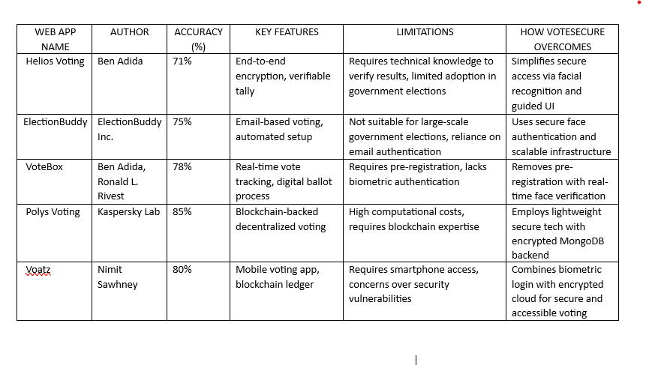
Table - 2: Literature Survey Chart

- API List:
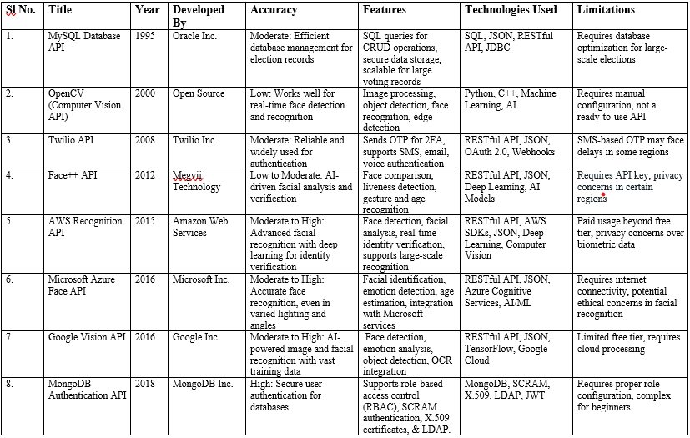
Table - 3: API List

Chapter – 3
TECHNOLOGIES USED

The development of VoteSecure relies on a range of modern technologies that together ensure secure authentication, real-time voting functionality, encrypted data storage, and a user-friendly interface. These technologies play a crucial role in creating a scalable, efficient, and tamper-resistant voting system that meets the demands of secure online elections.

- Face Recognition Integration using OpenCV and Deep Learning:
Facial recognition is at the core of VoteSecure’s authentication system, implemented using OpenCV and deep learning models. It captures the user's facial image and verifies it against the registered dataset to grant voting access.
- Role: Performs biometric authentication to verify voter identity before allowing access to voting features.
- Benefits: Prevents impersonation and duplicate voting, ensuring one-person-one-vote accuracy and high system security.

- MongoDB (NoSQL Database):
MongoDB is used as the primary database for storing voter data, facial features, and encrypted vote records. It supports flexible schemas and high-volume data handling.
- Role: Manages user profiles, candidate data, vote submissions, and authentication logs.
- Benefits: Offers scalability, high performance, and secure document-based storage that supports encrypted data operations.

- Node.js with Express.js:
The backend of VoteSecure is developed using Node.js along with the Express.js framework. It handles authentication requests, API routing, and secure server-side logic.

- Role: Provides backend logic, processes facial recognition requests, manages data flow between the frontend and database.
- Benefits: Ensures fast execution, supports RESTful APIs, and enables efficient handling of real-time operations.

- React.js (Frontend Framework):
React.js is used to build the responsive and interactive user interface of the application for both voters and administrators.
- Role: Creates dynamic UI components for login, vote casting, result viewing, and admin management.
- Benefits: Enhances user experience through fast rendering, reusable components, and smooth navigation.

Chapter – 4
SOFTWARE REQUIREMENT SPECIFICATION

- Overall Description:
The VoteSecure is a secure, web-based voting management application that leverages facial recognition to ensure a fraud-resistant and transparent election process. It is developed to address critical vulnerabilities in traditional voting methods, such as impersonation, manual errors, and vote tampering. The platform integrates modern technologies to streamline the entire election cycle from voter registration to vote casting and result computation. The application operates through a browser-based interface, providing accessibility across various devices including desktops and mobile web browsers. Voters can register by submitting personal details along with a facial scan, which is stored securely in a MongoDB database. During the voting process, facial recognition ensures that only the registered individual can cast a vote. Once authenticated, the voter is allowed to cast a single vote, which is encrypted and stored securely in the backend. VoteSecure uses a modular architecture, built using Node.js for the backend logic, OpenCV for biometric facial recognition, and MongoDB for encrypted data storage. The system features JWT-based session management, HTTPS communication for security, and a dashboard for administrators to manage elections, verify voters, and monitor results in real time. Its scalability, platform independence, and security features make VoteSecure a reliable solution for educational, institutional, and local elections, ensuring the integrity and efficiency of the electoral process.

- Product Perspective:
VoteSecure is a self-contained web application that performs all necessary functions to facilitate a secure and efficient voting process. It interacts with external libraries and services but does not depend on a broader system infrastructure.

- Facial Recognition Integration: Uses OpenCV and machine learning models for face detection and matching.

- Cloud-Backed Storage: Utilizes MongoDB for efficient and secure data operations.

- Cross-Device Access: Usable on desktops, laptops, and mobile browsers.

- Modular & Extensible Design: Easily adaptable for new biometric modules or encryption algorithms.

- Administrative Tools: Provides an intuitive dashboard for managing elections, verifying voters, and releasing results.

- Secure Communication: Enforces HTTPS and token-based authentication for all data exchanges.

- Constraints:
The development and implementation of the "VoteSecure" app face certain constraints that impact design and functionality.
- Internet Dependency: Requires a stable internet connection for real-time facial verification and vote submission.
- Hardware Access: Needs device camera permission to capture and process facial images.
- Privacy Regulations: Must comply with data protection laws and guidelines for handling biometric information.
- Performance Overhead: Real-time face detection may impact performance on lower-end devices.
- Security Scope: System must safeguard against both software and human errors during elections.

- Assumptions and Dependencies:
- Modern Browsers: Assumes users will access the system via modern browsers supporting camera access.
- Device Capability: Presumes all users have access to a functional camera and microphone (if needed for future use).
- Library Availability: Depends on OpenCV, Node.js, and encryption libraries for core functionality.
- MongoDB Services: Relies on the availability and performance of MongoDB for backend operations.
- Institutional Involvement: Depends on institutions for user data provisioning and candidate setup.

- Functions:
The VoteSecure web application provides a set of critical functionalities designed to ensure a seamless, secure, and fraud-resistant digital voting experience. Its biometric authentication system, secure vote casting process, and administrative tools collectively ensure that elections are conducted with high integrity and transparency. The system emphasizes accuracy, ease of use, and real-time processing to serve both voters and administrators effectively.

- User Registration: Allows users to register with personal information and a captured facial image for future biometric authentication.

- Facial Authentication: Verifies voter identity using real-time facial recognition matched against stored biometric data to prevent impersonation.

- Vote Casting: Enables authenticated users to securely cast their votes, ensuring one vote per user by disabling multiple submissions.

- Result Computation: Tallies votes in real time and provides accurate result reports on the admin dashboard.

- Admin Management: Allows administrators to set up elections, add or remove candidates, verify registered users, and monitor the voting process.

- Audit Logs: Maintains comprehensive records of all voting activities and system operations to ensure transparency and accountability.

- Security Measures: Applies data encryption, secure token-based sessions, and access controls to protect against unauthorized access or tampering.

- Performance Requirements:
The VoteSecure system is designed to ensure fast, secure, and seamless user interaction, even under heavy load. It is expected to perform biometric authentication, vote casting, and result processing with minimal latency. Real-time responsiveness is critical, especially for modules like face verification, admin dashboards, and vote tallying. The system must maintain stability during simultaneous voter logins, especially during high-traffic voting windows.
- Concurrent Sessions: Capable of supporting multiple users logging in and voting simultaneously without performance degradation.

- Authentication Speed: Facial recognition must process and verify identity within 2–3 seconds.

- Vote Submission: Votes must be securely cast and logged in real-time with <1 second confirmation.

- Admin Panel Responsiveness: Should load statistics, results, and logs within 3 seconds.

- System Uptime: Ensures 99.9% uptime during election periods for uninterrupted access.

- Database Performance: MongoDB queries and updates should complete within milliseconds.

- Scalability: Able to scale to hundreds of voters without requiring architectural changes.

- Standard Compliance:
VoteSecure adheres to recognized industry and legal standards to ensure the privacy, security, and accessibility of user data and system processes. From facial recognition to vote casting, every operation is designed to align with ethical and technological best practices.

- Data Privacy: Complies with GDPR and equivalent local data protection laws.

- Security Standards: Employs AES encryption for vote storage and HTTPS for all communications.

- Accessibility: Adopts WCAG guidelines to ensure interface usability across diverse user profiles.

- Coding Standards: Follows OWASP best practices to prevent vulnerabilities like SQL injection or token hijacking.

- API Standards: Backend services use RESTful APIs for structured, efficient client-server communication.

- Platform Consistency: Works across common browsers (Chrome, Firefox, Edge) and adapts to varied screen sizes.

- Software System Attributes:
The system is engineered to be modular, secure, and adaptable to various institutional needs. It ensures high availability, fast processing, and simple maintainability with built-in logging and administrative controls.
- Usability: Simple UI for voters and role-based admin views ensure ease of use.

- Reliability: Ensures uninterrupted operation during elections, with built-in fallback mechanisms.

- Security: All biometric and vote data is encrypted, with multi-layered access control.

- Scalability: Easily expandable to include additional roles or future voting features.

- Maintainability: Modular code design allows quick bug fixes and feature integration.

- Portability: Browser-based design ensures device-independent access.

- Efficiency: Optimized biometric algorithms and database indexing reduce server load and response times.

- Software and Hardware Requirements:
To ensure smooth deployment and operation, VoteSecure specifies certain hardware and software environments for both client and server sides. These specifications are essential for maintaining system responsiveness, supporting biometric computations, and ensuring secure data handling during high-load voting sessions. By defining clear requirements, the system minimizes compatibility issues, ensures data consistency, and provides a reliable experience across diverse user devices and institutional setups. Moreover, the chosen configurations allow for scalable performance, making it suitable for small-scale elections as well as large institutional deployments.

Software Requirements:
- Frontend: HTML, CSS, JavaScript.
- Backend: Node.js with Express for API logic and routing.
- Biometric Module: Python with OpenCV and facial recognition models.
- Database: MongoDB for secure, flexible NoSQL storage.
- Authentication: JWT (JSON Web Token) for session management.
- Testing Tools: Postman for API testing, Jest for backend logic validation.

Hardware Requirements:
- User Devices: Webcam-enabled desktop or mobile devices with modern browsers (Chrome v90+, Firefox v85+).
- Minimum Client Specs: 2GB RAM, dual-core processor, 1 Mbps internet speed.
- Admin/Server Devices: 8GB+ RAM, quad-core processor, SSD storage, and stable high-speed internet.

Chapter – 5
Design Phase

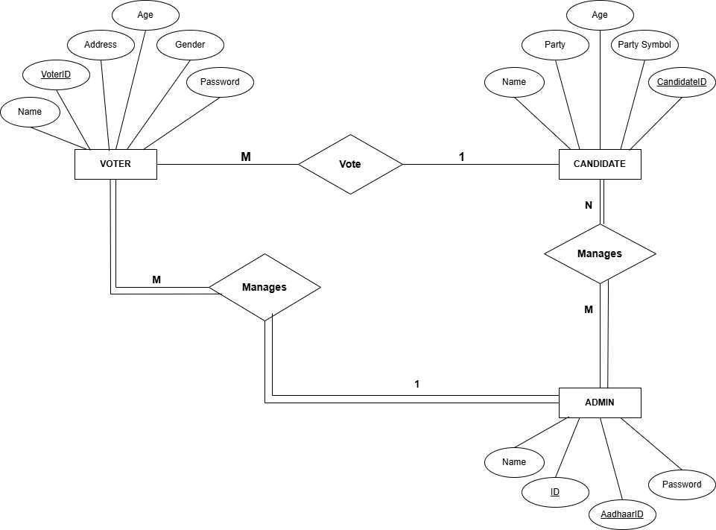
5.1 ER Diagram:
Fig – 1: ER Diagram

The ER diagram represents a digital voting system involving three primary entities, they are Voter, Candidate, and Admin. Each Voter has attributes such as VoterID, Name, Age, Address, Gender, and Password. Voters participate in the election process by casting their vote to a Candidate. This is shown through a many-to-one relationship, indicating that many voters can vote for a single candidate. The Candidate entity includes attributes such as CandidateID, Name, Age, Party, and Party Symbol. Candidates are the ones contesting in elections and are managed by Admins. Each candidate can be managed by multiple admins, and each admin can manage many candidates, forming a many-to-many relationship. The Admin entity is responsible for overseeing both voters and candidates. It contains attributes like ID, Name, AadhaarID, and Password. Admins also manage voters, forming another many-to-many relationship between Admin and Voter. This system ensures clear roles and responsibilities: voters can vote, candidates contest, and admins manage the entire process.

5.2 Architectural Design:
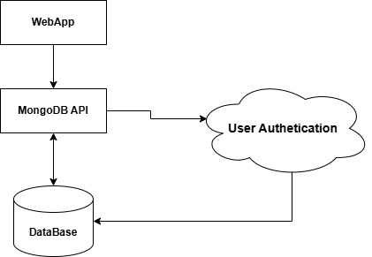

Fig – 2: Architectural Design
The diagram illustrates a simplified architecture for a web-based application utilizing a custom backend with MongoDB and integrated user authentication. The WebApp serves as the frontend interface that users interact with. It communicates with a MongoDB API, which acts as a middleware layer handling requests between the frontend and the backend services. This API is responsible for querying, inserting, or updating data in the Database (MongoDB). A crucial component of this architecture is User Authentication, which is invoked during login or secure data access processes. The MongoDB API interacts with the authentication module to verify user credentials before allowing access to protected resources. Once authenticated, users are allowed to read from or write to the database. This architecture enables a separation of concerns: the WebApp handles the user interface, the MongoDB API manages business logic and data transactions, and the Authentication module ensures secure access control. It promotes security, scalability, and modular development. This design is beneficial for applications needing custom backend logic, robust data handling, and secure user management, without relying on third-party BaaS platforms.

5.3 Data Flow Diagram:
- Level – 0 DFD:
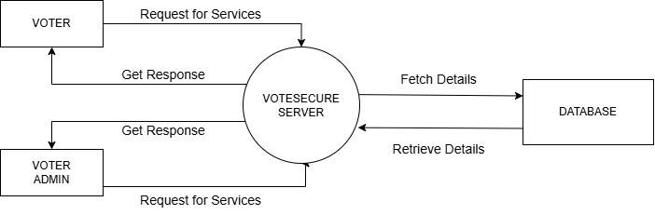

Fig – 3: Level – 0 DFD

The diagram illustrates a centralized server-based architecture for the VoteSecure application, designed to handle requests from different user roles—namely Voter and Voter Admin. Both the Voter and Voter Admin initiate Requests for Services, which are directed to the VoteSecure Server. This server acts as the central processing unit, managing business logic and communication with the backend database. Upon receiving a request, the VoteSecure Server performs the necessary operations by fetching details from the Database. These operations may involve validating voter identity, retrieving candidate lists, or updating voting records. Once the required data is retrieved from the database, the server processes it and sends back appropriate responses to the respective users. This architecture promotes a clear separation of roles, where the server ensures secure, centralized control over voting operations and access rights. It also simplifies data management and auditing by funneling all interactions through a single server. This design is particularly suitable for applications where reliability, role-based access, and data integrity are essential, allowing developers to enforce voting rules and securely manage sensitive election data.

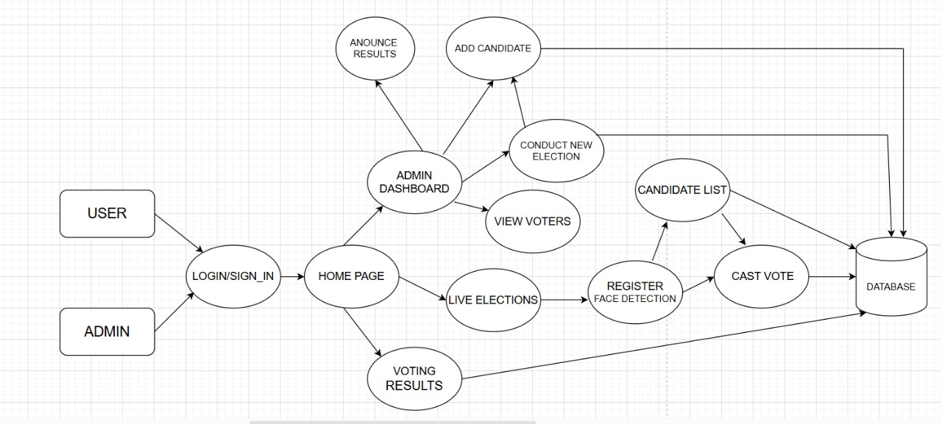
- Level – 1 DFD:
Fig – 4: Level – 1 DFD

The diagram illustrates the workflow of a Voting Management System using Face Recognition, outlining the interactions between users (Admin and Voter), system components, and the database. The system begins with two user types—Admin and User (Voter)—who both access the platform through a Login/Sign-In process. Upon successful authentication, they are directed to a common Home Page. From here, the Admin is granted access to the Admin Dashboard, which serves as the control center for election operations. The Admin can add candidates, conduct new elections, view registered voters, and announce election results. Each of these operations is connected to the Database to ensure data persistence and retrieval. On the other hand, regular users (voters) can navigate to the Live Elections section from the Home Page, where they are prompted to register their face using face detection technology before proceeding. Once registered, they can view the Candidate List, and upon selection, proceed to cast their vote. All these actions are recorded in the Database. The system ensures the integrity of the voting process by enforcing face registration prior to vote casting, minimizing the chances of duplication or fraud. Additionally, both Admin and Users can view Voting Results on the Home Page. The database plays a central role throughout, serving as the backbone for storing candidates, voter data, votes, and results. This ensures the system remains transparent, secure, and reliable.

5.4 Client-Server Model:
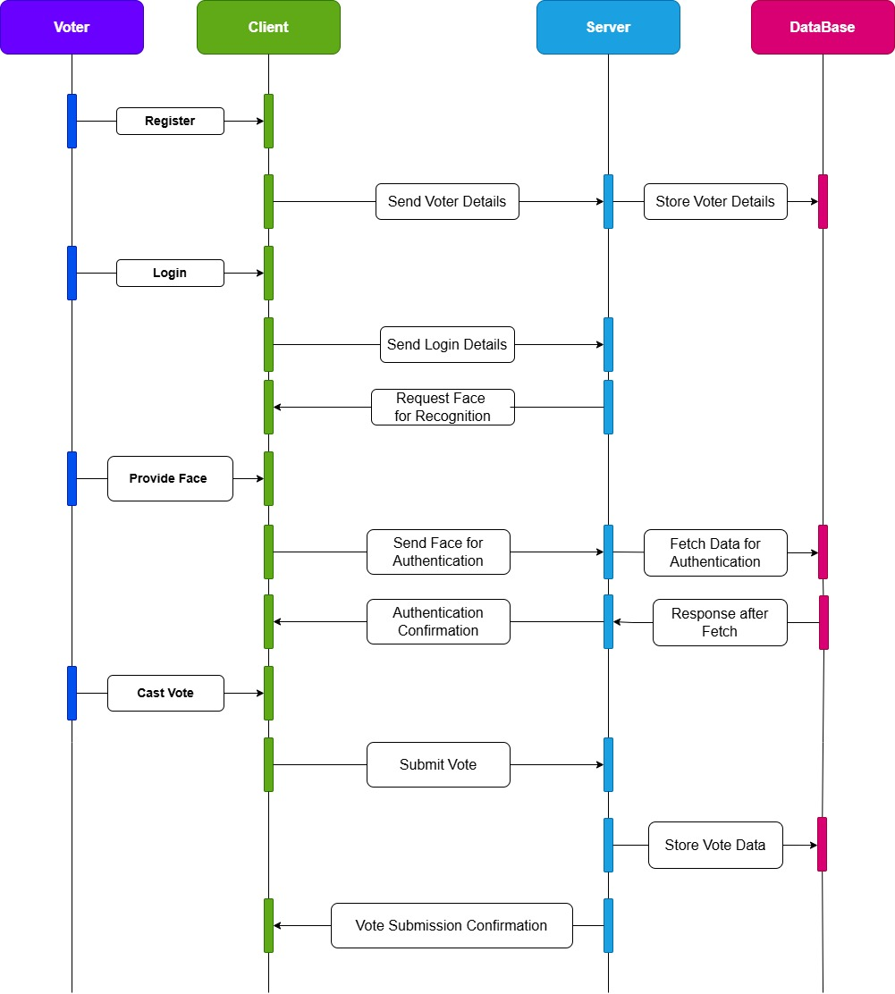

Fig – 5: Client – Server Model

The diagram presented is a sequence diagram that illustrates the end-to-end flow of interactions between the key components of the VoteSecure system: Voter, Client (frontend), Server (backend), and Database. The sequence starts with the registration phase, where the voter initiates the process by submitting their details via the client. The client sends this data to the server, which in turn stores it securely in the database. Upon successful verification, the server requests the voter's face data for biometric authentication. The voter provides the facial input, which is sent back through the client to the server. The server then fetches the registered facial data from the database to perform a comparison. Once verified, it sends an authentication confirmation back to the client. The voter selects a candidate and submits the vote via the client. The vote data is sent to the server and stored in the database. The server then confirms successful vote submission, completing the transaction. This diagram ensures clarity in how each layer communicates and highlights the system's reliability and security, especially in facial recognition-based authentication and vote storage processes. It reflects the structured, real-time flow that safeguards voter identity, prevents duplicate votes, and maintains system transparency.

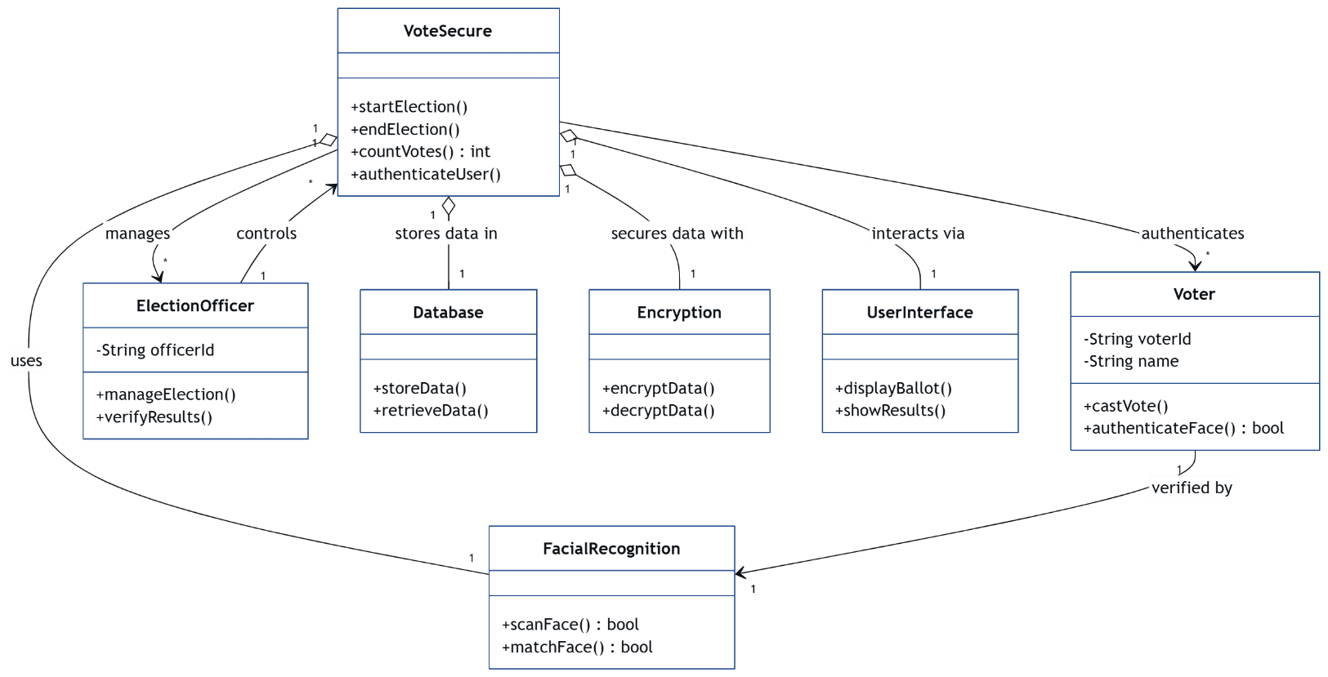
5.5 Class Diagram:
The class model represents the core structural design of the VoteSecure system by illustrating the main components (classes), their attributes, methods, and relationships. At the center is the VoteSecure class, which acts as the controller managing elections, counting votes, and authenticating users. This class interacts with various supporting modules. The ElectionOfficer class manages and verifies elections, invoking services of VoteSecure. Data persistence is handled by the Database class, which provides methods to store and retrieve election-related data. To ensure secure operations, the Encryption class offers encryption and decryption functionalities, safeguarding sensitive voting data. The UserInterface class allows the end-users (voters) to interact with the system through ballot display and result viewing. The Voter class captures voter identity and enables actions like casting votes and facial authentication. For biometric verification, the FacialRecognition class is used, allowing facial scanning and matching to verify voter authenticity. This diagram effectively captures the modular architecture, secure flow, and relationships among all essential system components involved in building a secure digital voting platform.
Fig – 6: Class Diagram

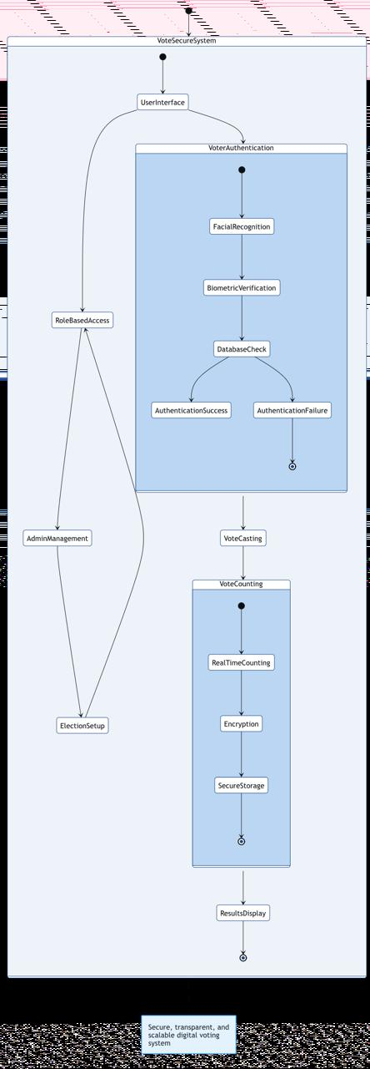
5.6 Advance State Diagram:

Fig – 7: Advance State Diagram
The state diagram models the high-level operational states of the VoteSecure system and how users transition through them. Initially, the voter accesses the system through the UserInterface, which then branches into RoleBasedAccess where the user role (admin or voter) is determined. If the voter proceeds, the system enters the VoterAuthentication state which involves FacialRecognition and BiometricVerification. These steps confirm the identity of the user via DatabaseCheck. Based on the outcome, the system transitions to either AuthenticationSuccess or AuthenticationFailure. If successful, the user progresses to VoteCasting, where they can cast their vote. The vote then flows into the VoteCounting module which performs RealTimeCounting, followed by encryption and SecureStorage of the vote. Finally, results are passed on to the ResultsDisplay state.

5.7 Use Case Diagram:
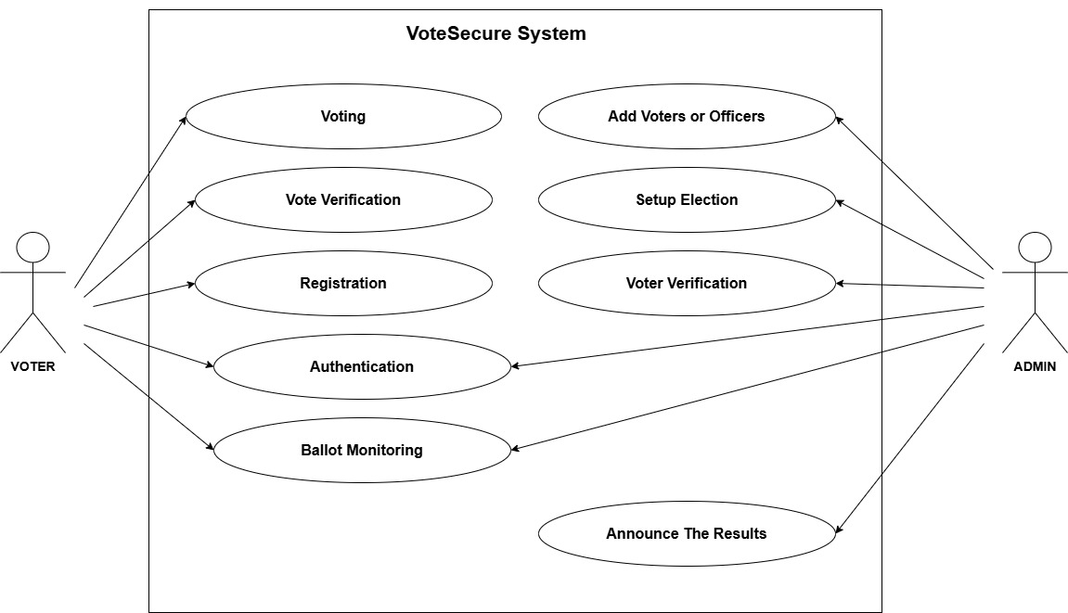

Fig – 8: Use Case Diagram

The use case diagram illustrates the interactions between students, faculty, and administrators with the Minor IT Sphere system. Students can access study materials, receive notifications, and interact with a chatbot. Faculty can manage and share study materials and access placement information. Administrators can add events and placements. The system aims to enhance student learning by providing access to resources and facilitating communication. It streamlines faculty work and supports administrative functions. By centralizing information and enabling efficient interactions, the Minor IT Sphere system strives to create a more connected and engaging learning environment for all stakeholders.

5.8 Sequence Model:
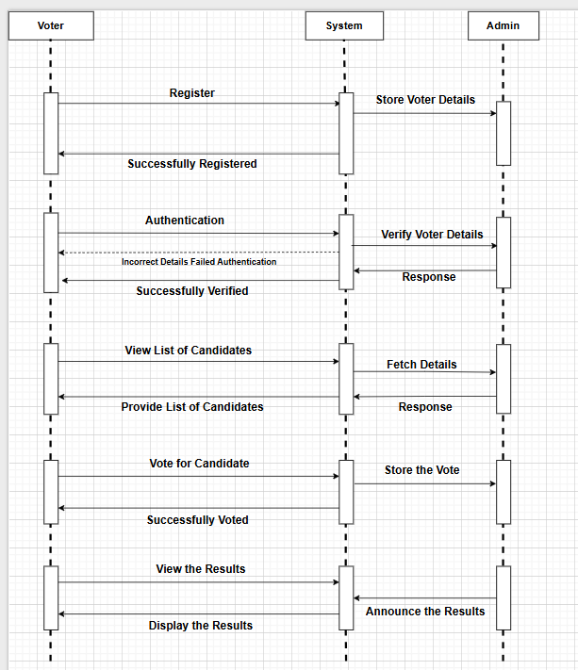

Fig – 9: Sequence Model

The sequence diagram showcases the detailed interactions between the Voter, Client, Server, and Database components in the VoteSecure system. The process begins with the voter initiating registration, where their personal details are sent by the client to the server, which in turn stores them in the database. When the voter proceeds to log in, the client sends the login credentials to the server, which then requests a facial scan for further verification. The voter provides their facial image, which is sent to the server by the client. The server then communicates with the database to fetch matching authentication records. Based on the results retrieved, the server confirms whether authentication has been successful. Upon successful verification, the voter can proceed to cast their vote. The vote is then submitted to the server, which stores the vote data in the database. Finally, a confirmation message is sent back to the voter. This diagram effectively outlines the real-time, step-by-step operations that enable secure and verifiable electronic voting using facial recognition in a client-server architecture.

Chapter – 6
Implementation Phase

- Module 1: Sender Functioning:
The Voter Registration and Sender Functioning Module is responsible for collecting user (voter/admin) data, preparing it for transmission, validating its format, and securely sending it to the backend system for processing. This includes capturing facial images during voter registration and transmitting them along with voter information for biometric authentication. The module ensures that each data field—such as name, ID, and image—is validated for correctness and completeness before submission. It uses encryption algorithms to secure sensitive data like passwords and facial scans before transmission. It also performs preprocessing on captured facial images, such as resizing and quality enhancement, to optimize the facial recognition accuracy. Additionally, this module handles real-time feedback to the user during the registration process, indicating success or error. It interacts with multiple backend APIs, including MongoDB for data storage and the facial recognition engine for image matching, forming the foundation of the system’s secure entry pipeline.

- User Input Collection: Captures voter/admin details and facial image using a webcam or device camera.
- Validation: Checks for correct data types, completeness, and format (e.g., image size, age ≥18, valid email).
- Encryption: Encrypts sensitive data like passwords and biometric data before transmission.
- API Integration: Connects with MongoDB backend and facial recognition engine through RESTful APIs.
- Error Handling: Detects incorrect inputs or failed submissions and notifies the user.
- Efficiency: Optimized for minimal delay during registration and authentication.

- Module 2: Connectivity:
The Connectivity Module establishes and manages secure communication between the frontend and backend components of VoteSecure. It supports the transmission of biometric data, API request handling, and notification delivery. This module acts as the backbone for all server interactions, ensuring that data packets—whether authentication requests, vote submissions, or result retrievals—are transmitted with integrity and speed. It leverages secure HTTPS protocols and RESTful API standards to maintain consistency and prevent unauthorized access during data transfer. JWT (JSON Web Token) is used for session management, ensuring each user’s identity is verified across interactions. The module also manages asynchronous tasks and retry mechanisms in case of temporary network failures. Additionally, it includes monitoring tools that track the latency, bandwidth usage, and error logs to improve system diagnostics. This ensures that all VoteSecure services remain operational and responsive under varied network conditions.

- RESTful API Communication: Facilitates interaction between user interface, authentication, and database layers.
- Session Handling: Maintains authenticated sessions using JWT tokens.
- Network Reliability: Ensures stable connections and retries failed requests during voting sessions.
- Notification Delivery: Uses Firebase Cloud Messaging to send election updates and voting alerts.
- Vote Logging: Transmits vote data securely to MongoDB with verification of voter status.

- Module 3: Receiver Functioning:
The Receiver Functioning Module processes incoming backend data, such as verification status, result updates, and user responses. It renders data into usable formats for the frontend and provides real-time feedback to users.
- Facial Recognition Output: Processes comparison results from the facial recognition model.
- Vote Confirmation: Receives confirmation of successful vote casting and displays messages.
- Result Display: Fetches vote counts in real-time and updates admin dashboard accordingly.
- Error Monitoring: Identifies incomplete data transmissions or face mismatches and returns relevant errors.
- UI Integration: Presents processed data (like results, user profile) in structured formats like tables or cards.

- Pseudo Code:

- Voter Registration:
Function RegisterVoter(voterDetails, facialImage):
IF voterDetails are complete AND facialImage is captured:
Encrypt data
Store voterDetails and facialImage in database
Show "Registration successful"
ELSE:
Show "Missing fields or image capture failed"
Function Register(userDetails):
Validate user details:
IF all fields are filled and valid:
Store user information in the database
Redirect to user selection (Student/Faculty)
ELSE:
Show error message "Please fill in all fields"

- Login and Facial Authentication:
Function LoginVoter(userID, password):
IF credentials match in database:
Prompt for facial scan
IF facial scan matches stored image:
Redirect to Voting Page
ELSE:
Show "Face authentication failed"
ELSE:
Show "Invalid login credentials"

- Cast Vote:
Function CastVote(voterID, candidateID):
IF voterID has not already voted:
Store vote in database
Show "Vote cast successfully"
ELSE:
Show "Duplicate voting not allowed"

- Admin Login and Setup:
Function AdminLogin(adminID, password):
IF admin credentials valid:
Redirect to Admin Dashboard
ELSE:
Show "Access denied"

- Add Candidate:
Function AddCandidate(candidateDetails):
IF admin authorized:
Insert candidateDetails into database
Show "Candidate added"
ELSE:
Show "Unauthorized access"

- View Results:
Function ComputeResults():
Fetch all vote entries
Tally votes for each candidate
Display results in descending order

- Send Notification:
Function SendNotificationToUsers(message):
FOR each registered user:
Push message using FCM

- Admin Adding Placement Information:
Function Logout():
Clear session data
Redirect to login screen

Chapter – 7
Testing Phase

- System Setup:
The system setup for testing involves preparing both the development and deployment environments to mirror real-world use cases. For the VoteSecure system, setup began by installing essential software and tools like Visual Studio Code for code editing, MongoDB Compass for database inspection, and Thunder Client for API testing. APIs were configured for user registration, facial recognition, and vote submission. Network connectivity, browser compatibility, and device configuration were tested to ensure stable interactions across modules and platforms.
- Environment Preparation: Configured VS Code, MongoDB server, and Node.js backend APIs.
- Device Setup: Testing was carried out using Windows desktop systems.
- Network Configuration: Ensured real-time API and database access with stable connectivity.
- Test Data Creation: Created user profiles, sample votes, and simulated facial images for test scenarios.
- Logging: Enabled backend logging to track authentication, submission, and error flows.
- System Compatibility: Verified functionality across Google Chrome and Mozilla Firefox browsers.
- Backup Mechanism: Ensured MongoDB backup for vote data and user credentials to safeguard against data loss during testing.

- Types of Tests Carried Out:
To ensure the WebApp's reliability and functionality, a variety of tests are conducted during the testing phase. Unit testing is performed to validate the functionality of individual modules like login, repository search, and notification handling.
- Unit Testing: Individual modules such as login, vote casting, and result computation were tested in isolation.
- Integration Testing: Checked whether frontend modules like registration and face authentication integrate seamlessly with backend services like MongoDB and Express.js.

- System Testing: Evaluated the entire application against its functional requirements such as vote submission, admin panel operations, and real-time verification.
- Usability Testing: Assessed interface clarity and ease of navigation for voters and admins during real-world simulations.
- Load Testing: Simulated multiple concurrent logins and voting operations to measure system performance and scalability.
- Regression Testing: Verified that new features (e.g., real-time result updates) did not disrupt previously working modules.
- Security Testing: Tested for authentication bypass, data integrity, session protection using JWT, and access control.

- Test Cases:
7.3.1 Unit Testing:
Table - 4: Unit Testing
Test ID | Test Case | Steps | Test Data | Expected Results | Observed Results | Status
1 | Vote Submission → Database Entry | Cast vote and verify DB update | New user details | Voter successfully registered | Voter details  Validated successfully registered | Done
2 | Face Recognition Validation | Match input face with registered database | Captured face | Voter authenticated | Face Matched and Access Granted | Done
3 | Voting Flow | Login → Face auth → Cast vote | Voter login + vote | Vote submitted and logged | Vote Recorded Successfully | Done
4 | Invalid Login | Input incorrect credentials | Wrong ID/password | Error message displayed | Invalid Login rejected with error | Done
5 | Duplicate Vote Prevention | Try to vote again using same credentials | Same user input | Access denied, error: already voted | Second vote attempt blocked | Done

7.3.2 Integration Testing:
Table - 5: Integration Testing
Test ID | Test Case | Steps | Test Data | Expected Result | Observed  Result | Status
1 | Voter Registration | Enter valid name, ID, age, image, password | New user details | Voter successfully registered | Voter details stored, registration confirmation displayed | Done
2 | Face Recognition Validation | Match input face with registered database | Captured face | Voter authenticated | Face matched and authentication success message shown | Done
3 | Voting Flow | Login → Face auth → Cast vote | Voter login + vote | Vote submitted and logged | Vote recorded in database, confirmation displayed | Done
4 | Invalid Login | Input incorrect credentials | Wrong ID/password | Error message displayed | Displayed "Invalid credentials, please try again" | Done
5 | Duplicate Vote Prevention | Try to vote again using same credentials | Same user input | Access denied, error: already voted | Blocked vote with alert: "You have already voted" | Done

Chapter – 8
RESULTS AND DISCUSSIONS

Results:
The VoteSecure web application successfully achieved its core objective of providing a secure, transparent, and user-friendly digital voting platform powered by facial recognition. During testing, the system effectively registered voters using biometric authentication, verified their identity in real time, and prevented duplicate voting through facial match validation. MongoDB was used for secure and encrypted data storage, handling user credentials and vote records without any data loss or inconsistency.
- Home Page: The VoteSecure homepage successfully delivers a visually appealing and informative interface and primary landing section highlights the core objective of secure and reliable voting.
- Voter Login page: The Voter Login page presents a straightforward form that allows users to securely enter their Voter ID and password. A clear “Login” button and links for password recovery and account creation also.
- Voter Signup page: The Voter Sign-Up page collects necessary voter information including name, Voter ID, age, gender, address, and password confirmation. The form is logically structured with helpful placeholders and a prominent “Sign Up” button.
- Admin Login Page: The Admin Login page mirrors the voter login design, providing a focused interface with fields for Admin ID and password. The layout is uncluttered and promotes quick access.
- Admin Signup page: The Admin Sign-Up form requires details like name, Admin ID, authorized ID, and password setup. It uses a structured input flow and clear instructions for admin registration.
- Reset Password page for Admin and Voter: The Reset Password page provides a minimal yet functional form with fields for Voter ID, new password, and confirmation.
- Admin and Voter Dashboard page: The Admin Dashboard presents a centralized interface with clearly labelled buttons for managing election operations such as adding candidates, viewing voters, and announcing results.
- Conduction of Election page: The Conduct Election page allows administrators to set up an election by entering details like election name, type, start and end dates, time, and selecting candidates from a dynamic list.

- Candidate and Voters list: The Voter List page displays registered voters with details like name, age, address, gender, Voter ID, voting status, and an option to delete entries.
- Election Results: The Election Results page displays the outcome of the election in a visually appealing format.
- Facial Recognition: Registration and Verification: The facial recognition system successfully registered the user's face and accurately verified it during the authentication process, as indicated by the verification confirmation popup.
- Casting Vote: The system successfully presented the list of candidates and recorded the selected vote upon submission.
- Final Page after Voting: After casting the vote, the system redirected the user to a confirmation page thanking them and indicating that results would be announced post-election.

Discussion:
The development and implementation of VoteSecure demonstrated how biometric technologies can redefine secure and reliable mechanisms.
- Home Page: The clear layout and intuitive navigation enhance user engagement and build trust in the system. By emphasizing security, transparency, and advanced technology, the design effectively communicates the system's credibility and purpose to first-time users.
- Voter Login Page: The clean layout improves user focus, and the minimal input fields ensure fast access. The use of a gradient background adds visual appeal while maintaining simplicity in user interaction.
- Voter Signup page: The form supports easy user onboarding with clear labeling and a modern UI. The inclusion of gender selection and password confirmation enhances data accuracy and security for first-time voters.
- Admin Login page: Consistency in design with the voter login ensures ease of use for administrators as well. The form supports secure access to admin functionalities without unnecessary distractions.
- Admin Signup page: The structured format ensures only authorized personnel can register, supporting secure system control. Validation fields like “Authorized ID” reinforce role-based authentication in the admin process.
- Reset Password page for Admin and Voter: The simple and distraction-free design ensures users can quickly recover access without confusion.
- Admin and Voter Dashboard page: Both dashboards are designed with simplicity and clarity, enhancing user interaction for their respective roles.
- Conduction of Election page: This interface ensures a smooth and guided election setup process, minimizing manual errors through structured inputs.
- Candidate and Voters List: Both lists provide a transparent and manageable way for the admin to oversee the election database.
- Election Results: This results page serves as the final output of the voting process.
- Facial Recognition: Registration and Verification: The system demonstrates effective face matching even under varying lighting conditions, highlighting the robustness of the recognition algorithm in real-world scenarios.

- Casting Vote: The interface provided a clear and user-friendly voting experience, ensuring that the vote was cast securely and without ambiguity.
- Final Page after Voting: The final page reinforces trust in the system by confirming vote submission and maintaining election integrity through delayed result disclosure.

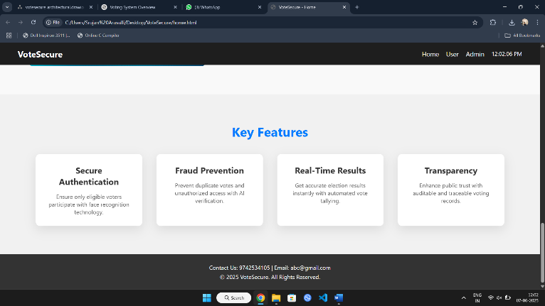
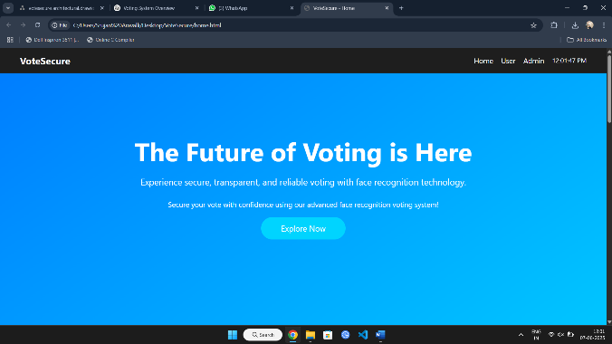
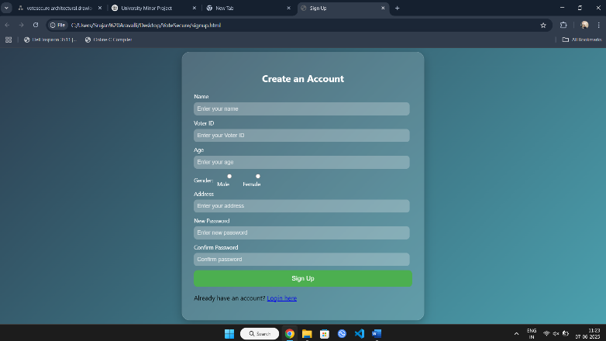
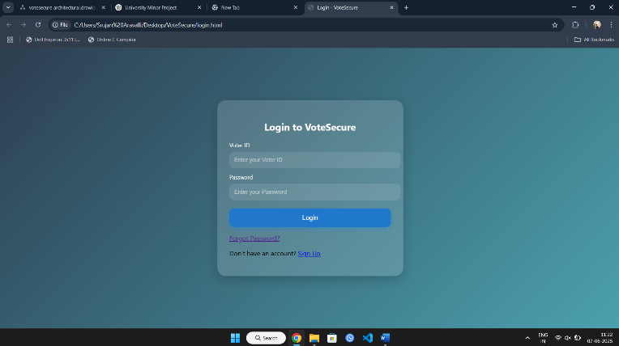
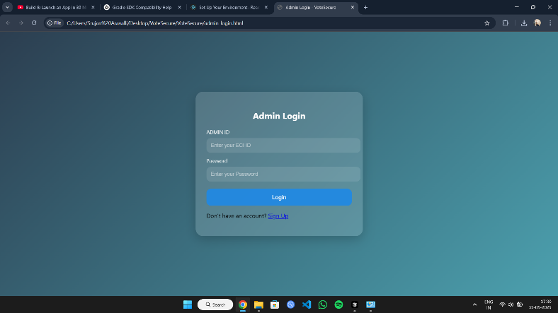
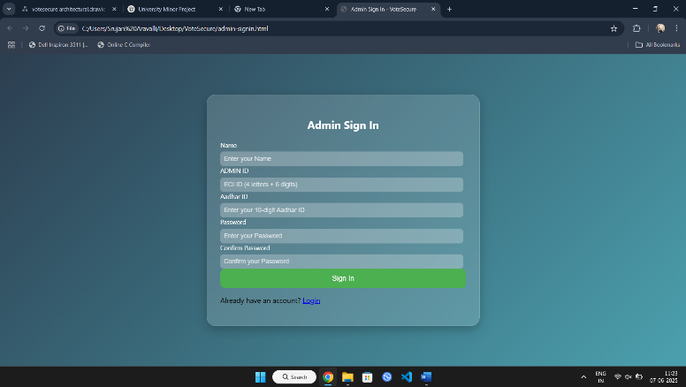
Screenshots:
Fig – 10: Home Page
Fig – 11: Voter Login and Signup page
Fig – 12: Admin Login and Signup page

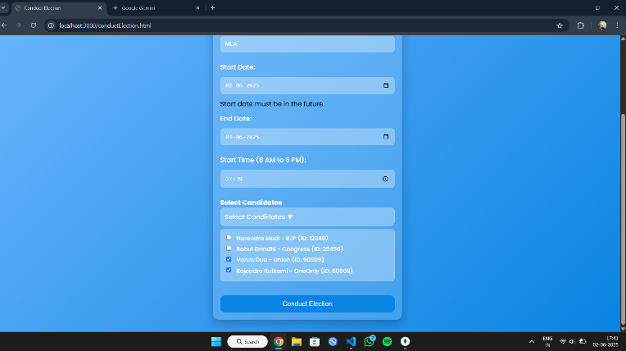
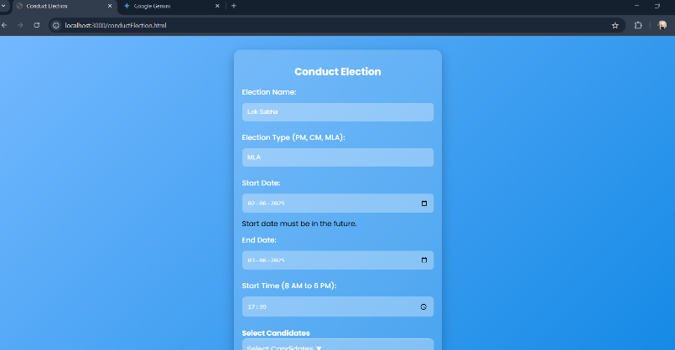
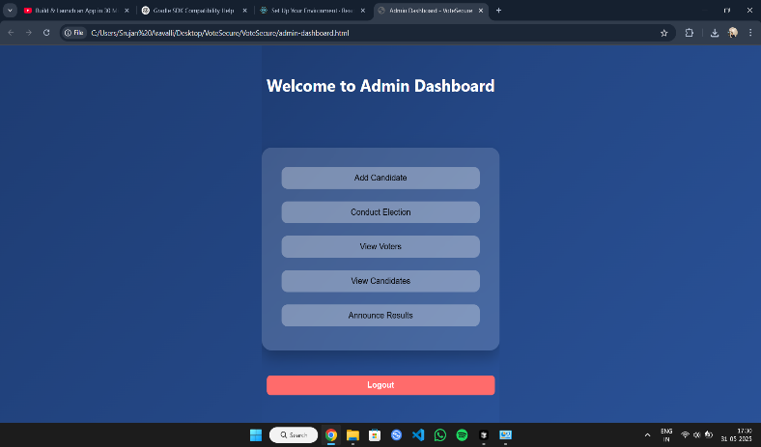
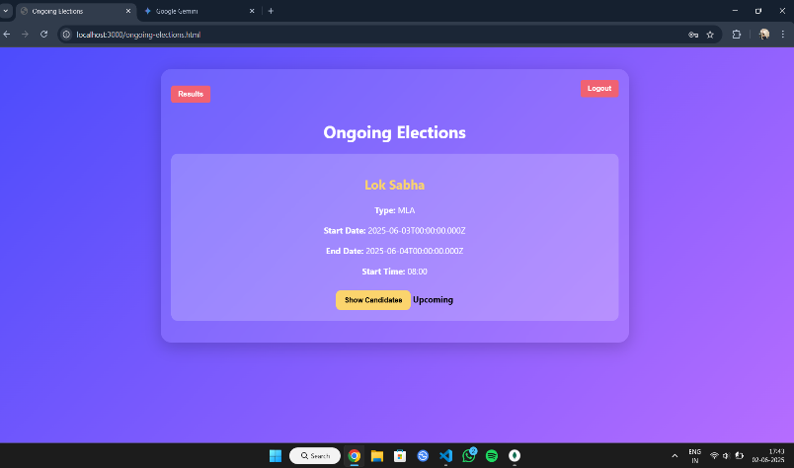
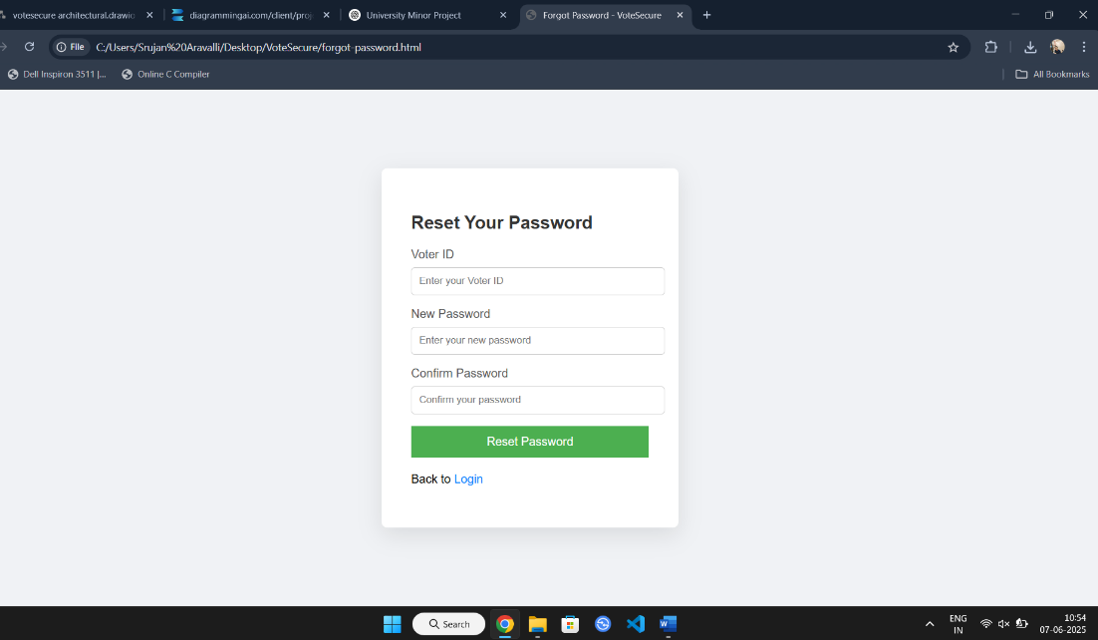
Fig – 15: Conduction of Election page
Fig – 14: Admin and Voter Dashboard pages
Fig – 13: Reset Password for Admin and Voter page

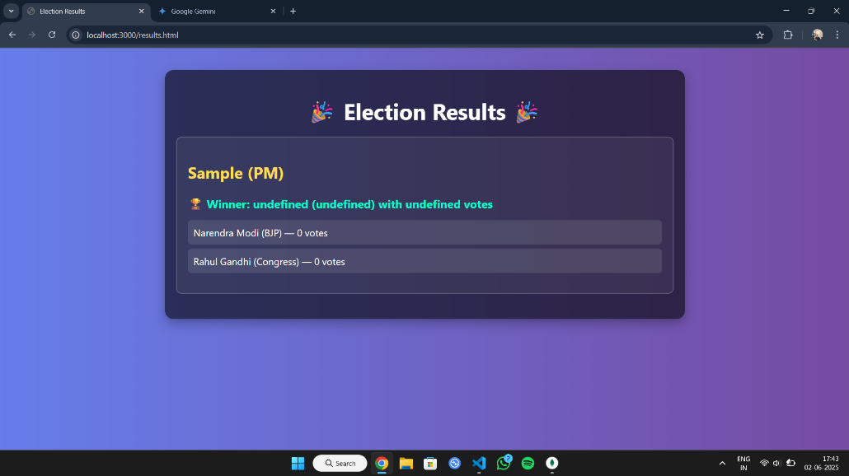
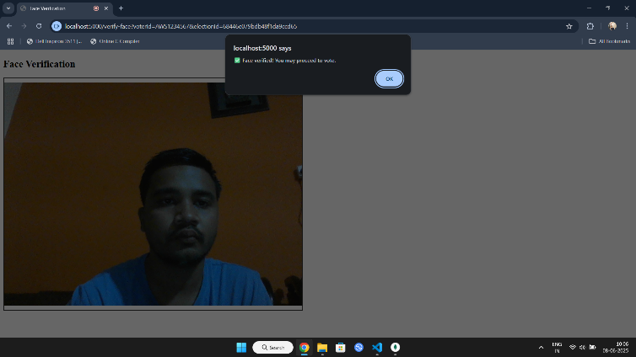
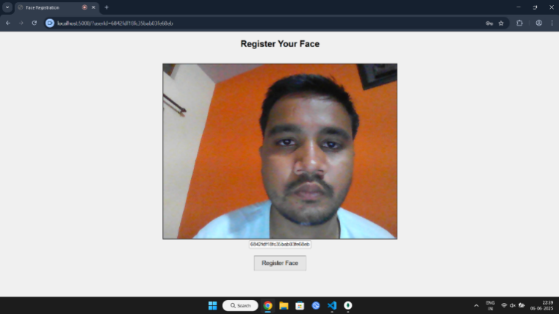
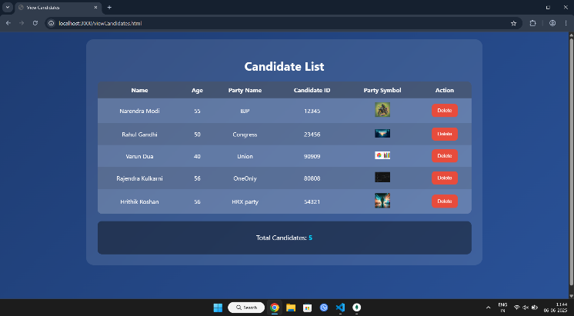
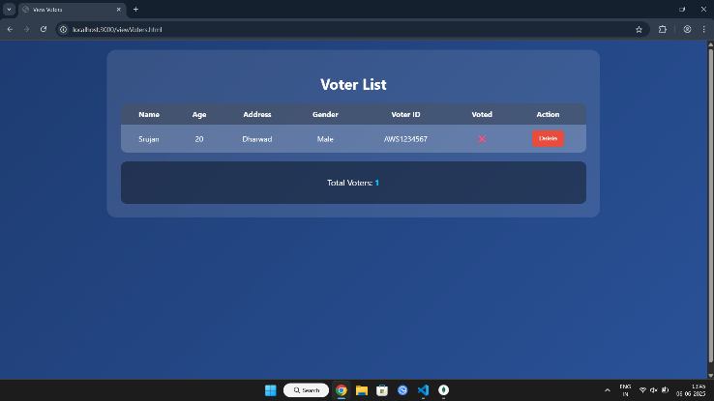
Fig – 17: Election Results
Fig – 18: Facial Recognition: Registration and Verification
Fig – 16: Candidate and Voter List

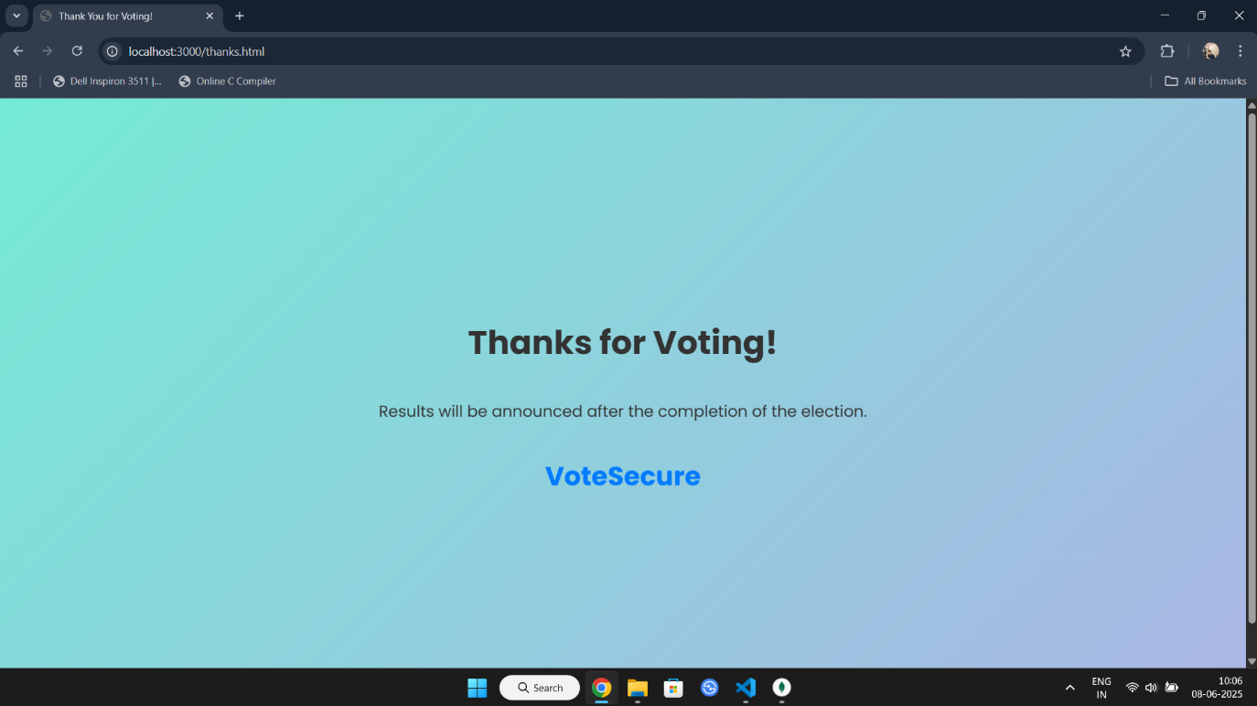
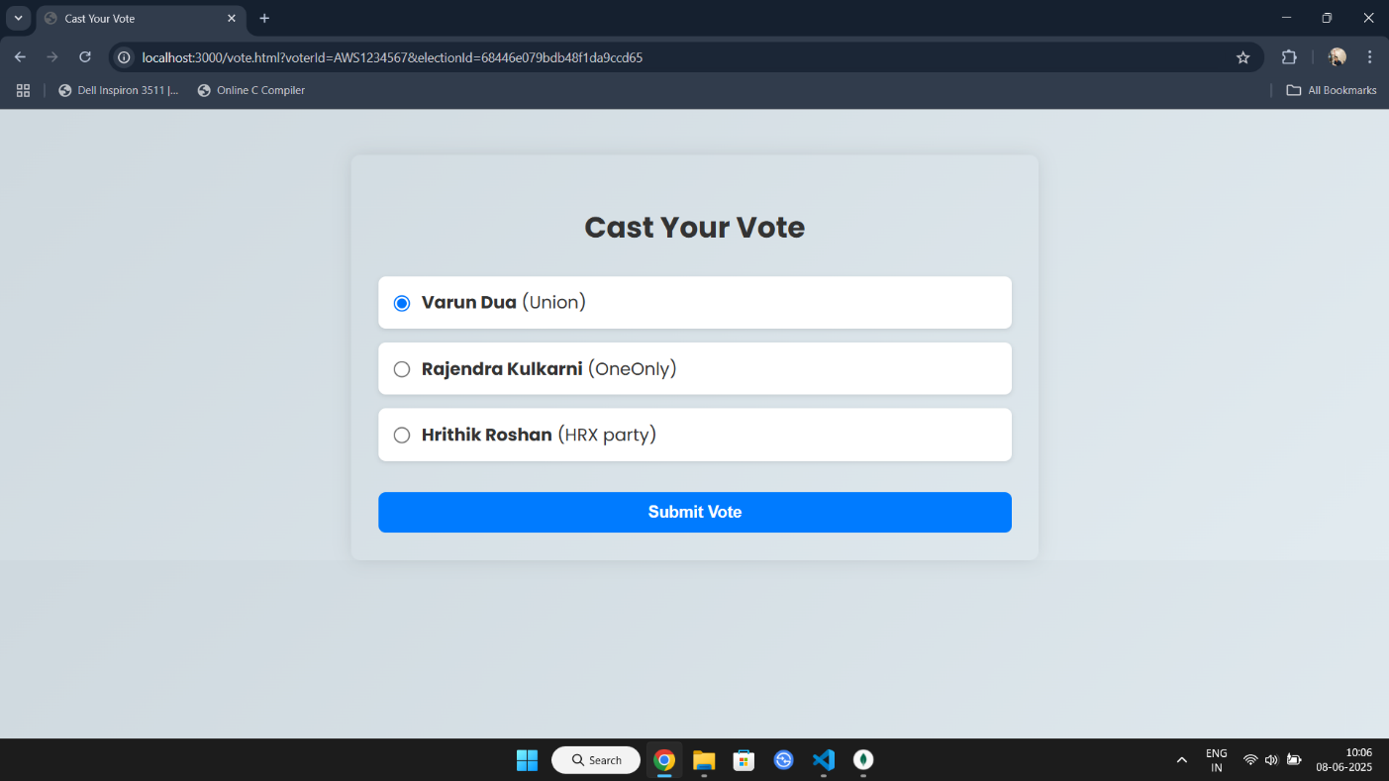
Fig – 20: Final Page after Voting
Fig – 19: Casting Vote

Chapter – 9
APPLICATION

The VoteSecure web application has wide-ranging applications across institutional, governmental, and organizational election scenarios. By integrating biometric facial recognition and real-time result computation, the system redefines traditional voting models with improved security, efficiency, and user trust. Below are key applications of the VoteSecure system:

- Educational Institution Elections:
Secure platform for conducting student body or council elections within colleges and universities. Prevents impersonation and ensures every student votes only once.

- Corporate or Internal Organizational Elections:
Used to conduct board member voting, employee polls, or committee selections securely in companies or NGOs. Supports remote, verified participation via biometric login.

- Government and Local Body Elections:
Ideal for municipal or regional elections where digital voting can reduce logistical challenges. Face recognition ensures voter identity without manual verification processes.

- Online Polling with Identity Validation:
Conduct online polls and surveys requiring real-user validation. Eliminates multiple submissions by the same user.

- Biometric Voter Enrollment Systems:
Acts as a base for large-scale voter registration with facial data and demographic details. Enables quick identity verification in future elections.

- Secure Event-Based Voting:
Used in decision-making activities like community resolutions, club elections, or shareholder voting. Ensures integrity with encrypted vote logging and facial confirmation.

- Result Monitoring and Transparency:
Offers real-time vote counting and public result dashboards to boost election transparency. Reduces manual errors and increases public trust in the system.

Chapter – 10
CONCLUSION

The VoteSecure project presents a secure, scalable, and modern approach to managing elections using web technologies and facial recognition. It successfully addresses long-standing challenges in traditional voting systems, including identity fraud, double voting, and manual result errors. By integrating biometric authentication, encrypted vote handling, and real-time result computation, the system delivers a transparent and tamper-proof voting process.
- Enhanced Election Security:
• Prevents impersonation through biometric facial recognition, ensuring only registered voters can cast their vote.
- Improved Voter Experience:
• Offers a smooth, intuitive voting process with facial login, eliminating lengthy manual verification.
- Administrative Efficiency:
• Simplifies election setup, candidate registration, and result monitoring through a centralized admin dashboard.
- Real-Time Result Accuracy:
• Enables instant vote tallying and visual result display, reducing delay and manual errors.
- Data Integrity and Privacy:
• Implements robust encryption standards and secure communication protocols, protecting sensitive voter data.
- Scalable System Design:
• Can be adapted for use in educational institutions, organizations, and local government elections.
- Transparency and Trust:
• Provides audit logs, real-time monitoring, and verification mechanisms that enhance the credibility of the election process.

Chapter – 11
FUTURE OF SCOPE

While VoteSecure has been designed to meet the immediate needs of secure digital voting, its potential goes far beyond its current capabilities. Future improvements can elevate the system to serve larger populations, higher-stakes elections, and more advanced use cases.

- Multi-Modal Biometric Authentication:
Integrate additional biometric methods such as fingerprint or iris scanning to enhance verification robustness.
- Offline Voting Mode with Sync:
Allow votes to be cast offline and synced securely when internet connectivity resumes, especially for remote areas.
- AI-Based Fraud Detection:
Use machine learning models to detect unusual voting patterns and flag suspicious activities in real time.
- Voter Education Module:
Add guided tutorials, FAQs, and simulation environments to educate new users about the digital voting process.
- Blockchain Vote Ledger:
Implement blockchain to further secure vote logs, making vote tampering practically impossible.
- Language Localization and Accessibility:
Support multiple regional languages and include accessibility features for visually impaired or differently-abled users.
- Integration with Government Portals:
Enable seamless voter verification through existing national ID systems like Aadhaar or other e-governance tools.

REFERENCES

- OpenCV.org, Face Detection and Recognition Using Haar Cascades – https://opencv.org
Official documentation for face detection techniques used in VoteSecure’s real-time facial authentication.

- MongoDB Documentation – https://www.mongodb.com/docs Provides information on schema-less database design, used for storing voter data and encrypted votes.

- Node.js, Express Backend Development – https://expressjs.com Backend framework references used to build REST APIs for registration, login, and voting operations.

- JWT Authentication for Web Applications – https://jwt.io/introduction Guide for implementing secure, token-based authentication for session management in VoteSecure.

- Jain, A. K. et al., “Biometric Systems: Security and Design Challenges,” IEEE Transactions
Discusses challenges in biometric authentication, guiding VoteSecure’s encryption and anti-spoofing features.

- “Facial Recognition in Modern Voting,” IJCA, 2022 Validates the effectiveness of facial recognition in reducing fraud in e-voting systems like VoteSecure.

- NIST Face Recognition Vendor Test (FRVT) Reports – https://www.nist.gov/programs-projects/face-recognition Benchmarks facial recognition accuracy, informing VoteSecure’s model selection.

- “Smart Voting System through Face Recognition,” ResearchGate, 2021
Offers architectural insights into facial recognition-based voting systems applied in VoteSecure.

- Cybersecurity Best Practices for Election Systems – US-CERT – https://www.cisa.gov
Provides guidelines for securing digital voting systems against threats, applied in VoteSecure's architecture.

